WEEK 4 GITHUB:

3) Retrieve the employee numbers of all employees who work on project located in Bengaluru,

Hyderabad, or Mysuru

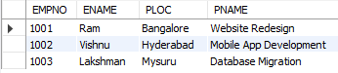

5) Write a SQL query to find the employees name, number, dept, job_role, department location

and project location who are working for a project location same as his/her department

location.

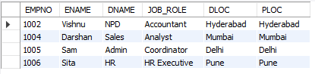

4) Get Employee ID’s of those employees who didn’t receive incentives

